Development system requirements: Windows 7 SP1

1. Download and install Qt 5.3.1:
http://qt-project.org/downloads
http://download.qt-project.org/official_releases/online_installers/qt-opensource-windows-x86-1.6.0-4-online.exe
Install Qt 5.3 as shows in Figure 1
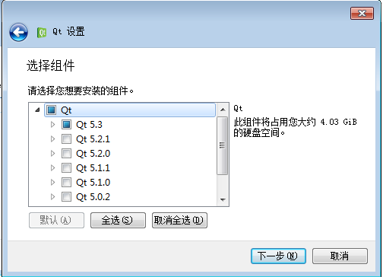
Figure 1 : Select Qt 5.3

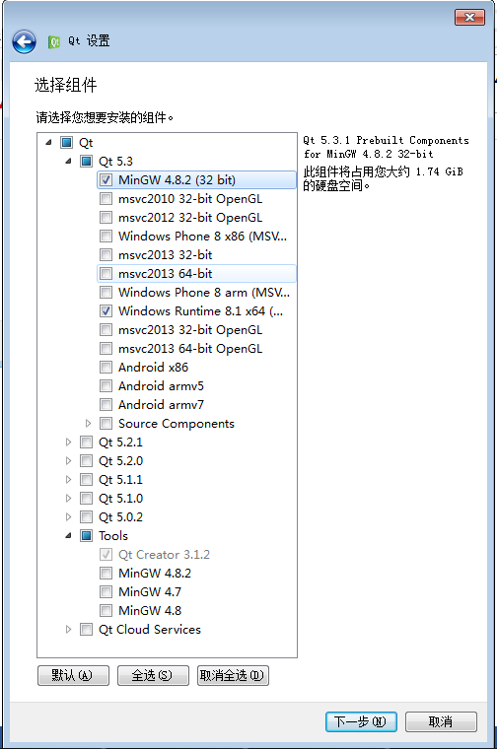
Figure 2: Untick unecessary packages
As shows in Figure 2, untick unecessary packages. Here I unticked Android and windows phone related packages.
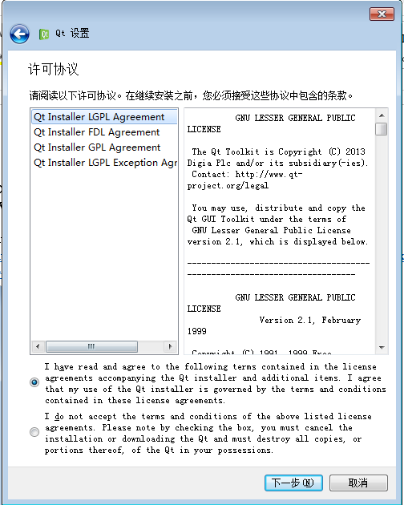
Figure 3: Lisence agreement
Choose the lisence and agree to the lisence.

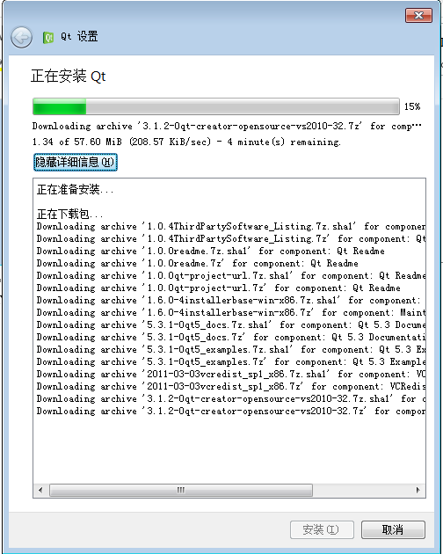
Figure 4: Installation process
The installation process takes about 1hour which depends on your network status.

2. Run Qt Creator and import the program source code

The github link for software is :
https://github.com/Shawn-Hu/Qt_Example.git

Command to download source code:
Git clone https://github.com/Shawn-Hu/Qt_Example.git

The RC1 release can be found in:
https://github.com/Shawn-Hu/Qt_Example/archive/RC1.tar.gz
Download the RC1.tar.gz package or use git clone to download the source code to local disk.

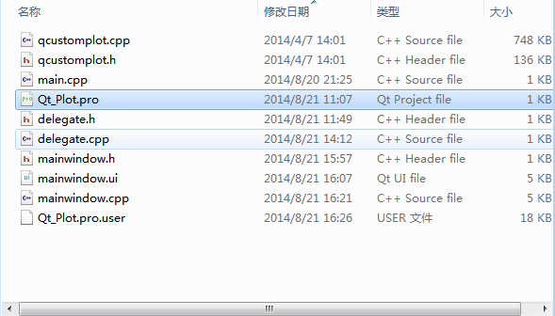
Figure 5:Files in Qt_Plot
Doubel click Qt_plot.pro. Qt Creator will open the project by default.
The folder structure looks like this:

├── Qt_Plot # This is the development code folder
│ ├── Qt_Plot.pro
│ ├── Qt_Plot.pro.user
│ ├── delegate.cpp
│ ├── delegate.h
│ ├── main.cpp
│ ├── mainwindow.cpp
│ ├── mainwindow.h
│ ├── mainwindow.ui
│ ├── qcustomplot.cpp
│ └── qcustomplot.h
├── README.md
├── Test Cases.xls # This is the manual test case document
├── User Mannual.doc
└── build-Qt_Plot-Desktop_Qt_5_3_MinGW_32bit-Debug
├── Makefile
├── Makefile.Debug
├── Makefile.Release
├── debug
│ ├── Qt_Plot.exe
│ ├── delegate.o
│ ├── main.o
│ ├── mainwindow.o
│ ├── moc_delegate.cpp
│ ├── moc_delegate.o
│ ├── moc_mainwindow.cpp
│ ├── moc_mainwindow.o
│ ├── moc_qcustomplot.cpp
│ ├── moc_qcustomplot.o
│ └── qcustomplot.o
├── mvcdata.back.csv
├── mvcdata.csv
├── release
└── ui_mainwindow.h

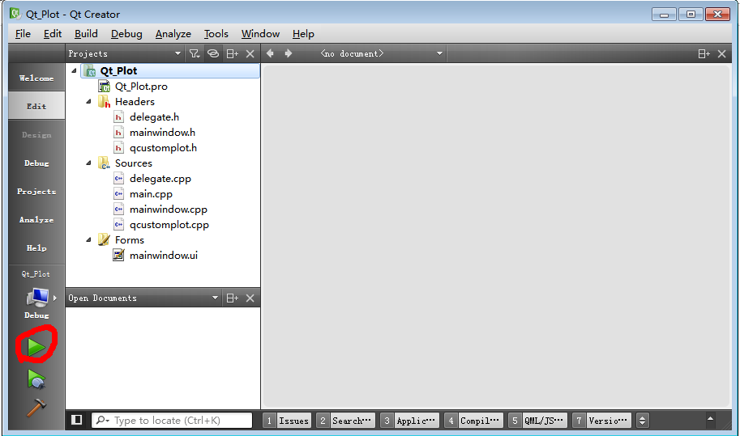
Figure 6: Run the program
Click the green arror to launch the program.

3. Program function introduction
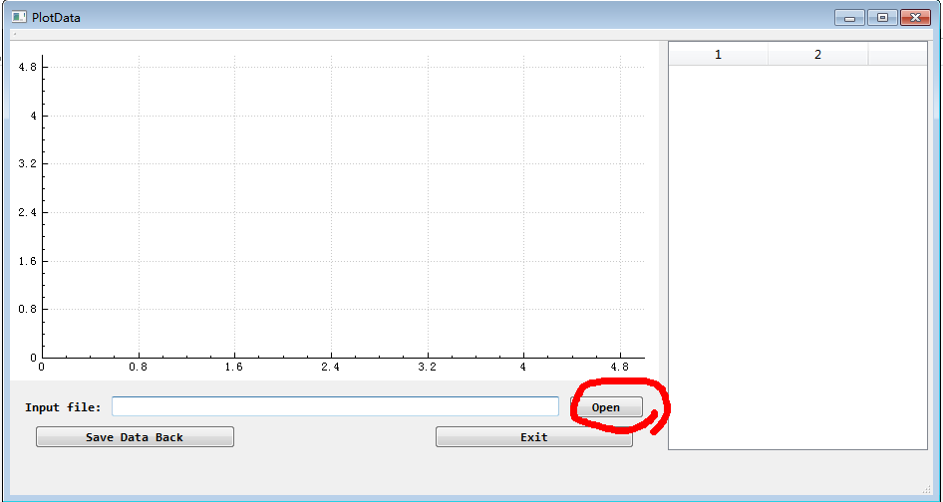
Figure 7: Open file
Program interface should look like this. Click Open button to choose the CSV file you want to plot. The format of the CSV file should follow the example mvcdata.csv file.

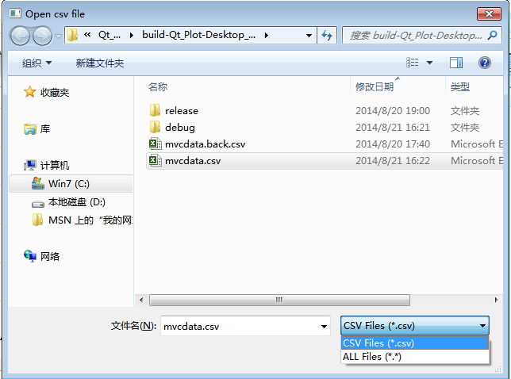
Figure 8: Select the data source
Choose the mvcdata.csv file and the software will open the file and plot the data.
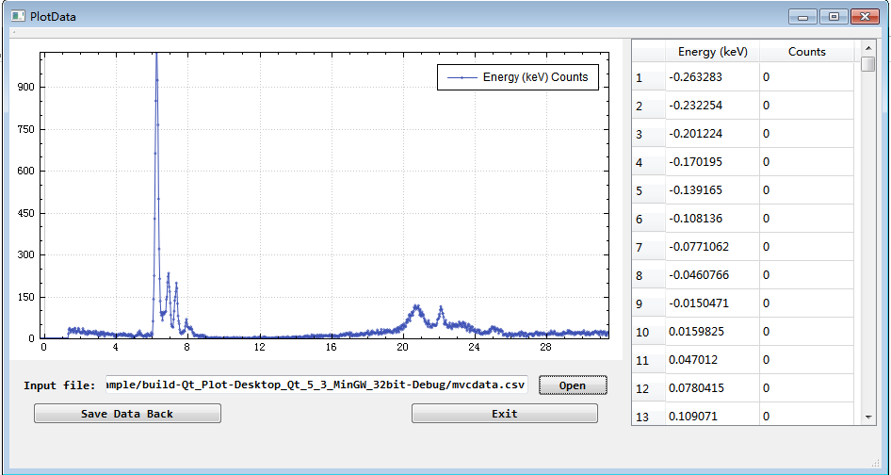
Figure 9: Data plot and display use MVC

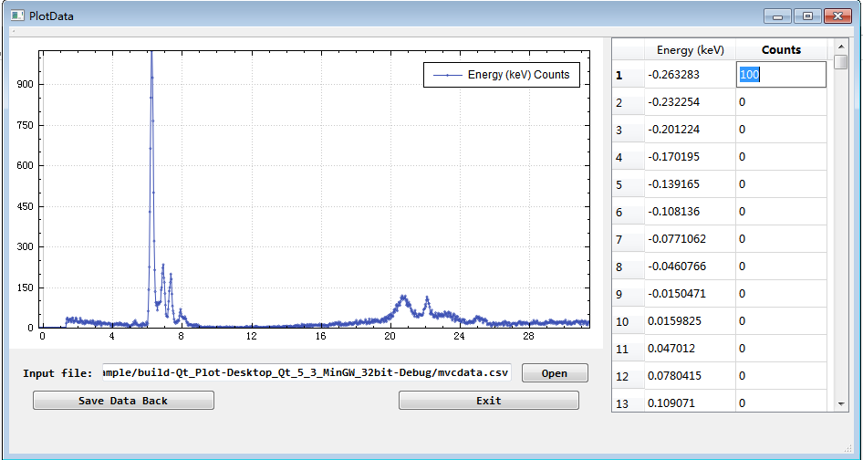
Figure 10: Edit data in the table
To edit the data on the right table, double click on the cell or select the cell and press enter and input the number you want to change.

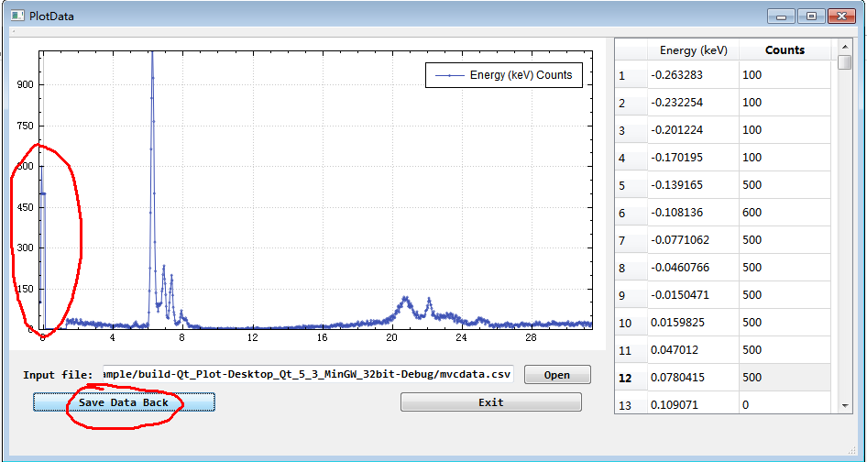
Figure 11: Save data back to .csv file
Click Save Data Back button on the left to save the data back to mvcdata.csv file. After the file changes, the plot also updates itself to reflect the changes of the file data. Red circled in Figure 11.

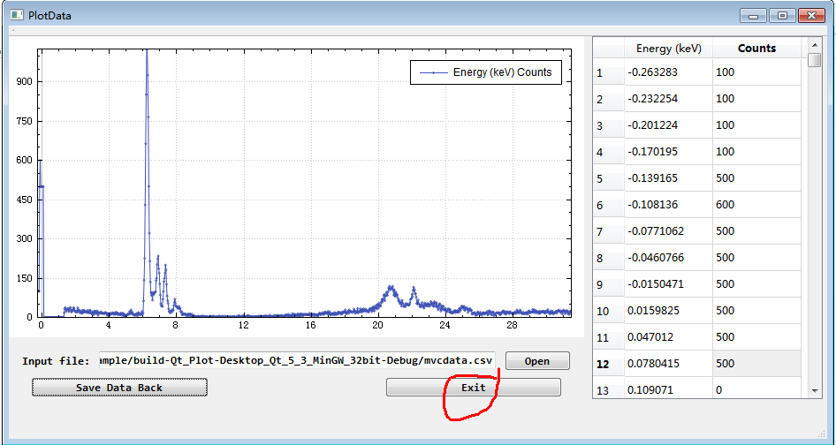
Figure 12: Exit the program
Click the Exit button to exit the program.

Since it is a demo program. There are still more error handling functions need to be added to the program. For example, handle unexpected .csv file format, handle unexpercted data input from user. The layout can also be improved.

